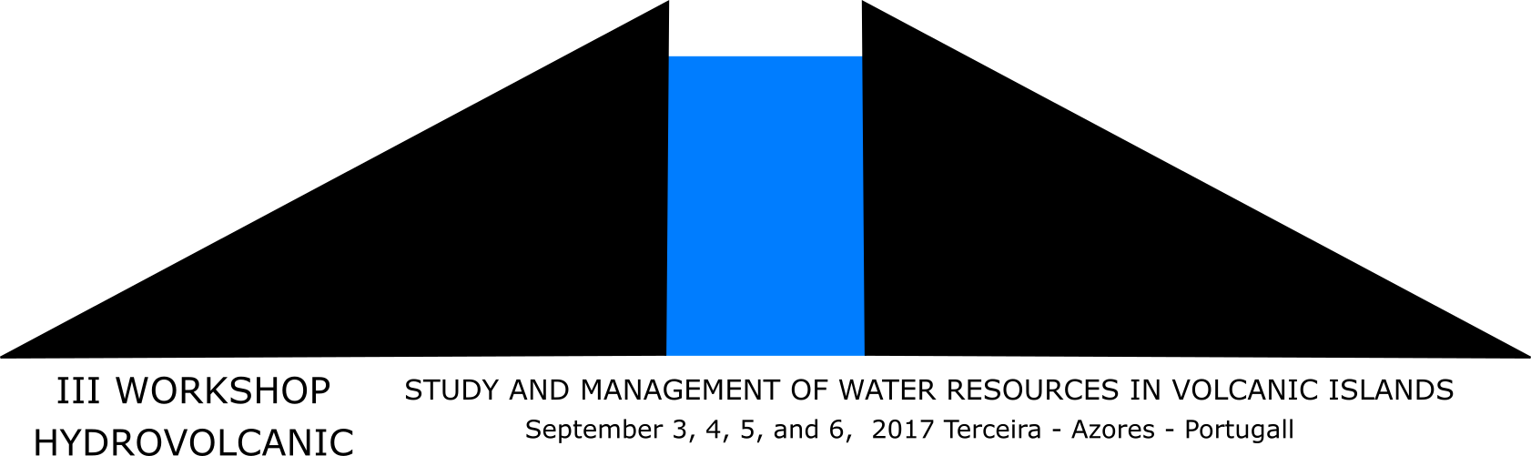

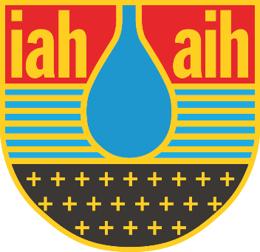

III ​​​HydroVolcanic2017
Study and management of water resources in ​volcanic islands

Rules for Abstracts and Extended Abstracts

The participants will have two possibilities, according to their choices: send an Abstract (maximum 2 pages), or an Extended Abastract (maximum 4 pages) by 30 June 2017

According to the quality of the received documents, by decision of the Scientific Committee, after the Conference some authors can be invited to send a full paper to publish as a book chapter which will be negociated with a publisher

Terceira island, Portugal, September, 03-06, 2017
GENERAL RULES

The authors must comply with the following rules for the Abstracts and Extended Abstracts:

- Deadline: 30 June 2017
- Dimension of the page: A4
- Margins (cm): Up, 3.0, Down, 2.5; Left, 3.0; Right, 2.0
- Title: MsWord, Times New Roman, size 12, bolt, capital letters, single space, centred
- Authors: MsWord, Times New Roman, size 11, bolt, single spaced, centred
- Adress: MsWord, Times New Roman, size 9, single spaced, centred
- Text: Word processor MsWord, Times New Roman, size 11, single space, justified
- No spaces between paragraphs
- No advance on the first line of each paragraph
- Write the text without any formulae

Please send your Abstract or Extended Abstract by e-mail to hydrovolcanic2017@uac.pt. More information can be obtained by the same e-mail address if the instructions are unclear or unspecific.

SPECIFIC RULES FOR ABSTRACTS

- Maximum length: 2 pages
- Apart from the title, the subtitle “Abstract” must be added in the beginning of the text
- Just a second subtitle is allowed in the final of the text “References”
- A chapter for ”Acknowledgments” can be introduced before the ”References”
- No titles or subtitles will be used apart from the two previously defined
- Figures or tables can be used in the text
- Keywords: In the final of the abstract (maximum 5)
In the following line, please refer in what topic you want your document to be framed (see 1st Circular, Topic A to L).

SPECIFIC RULES FOR EXTENDED ABSTRACTS

- Maximum length: 4 pages
- The Extended Abstract must begin with “Abstract” (maximum half a page), followed by one empty line, the “Keywords” (maximum 5), and again 2 empty lines
- Sub-titles:
1. HYDROGEOLOGY (TIMES NEW ROMAN, SIZE 11, BOLT, CAPITAL LETERS, SINGLE SPACED, JUSTIFIED,)
2.1. Hydrogeology (Times New Roman, size 11, bolt, single spaced, justified, with a line space before each subtitle)
2.1.1. Hydrogeology (Times New Roman, size 11, single spaced, justified, with a line space before each subtitle)
2.1.1.1. Hydrogeology (Times New Roman, size 11, italic, single spaced, justified, with a line space before each subtitle)
- A chapter for ”Acknowledgments” can be introduced before the ”References”
In the last line, please refer in what topic you want your document to be framed (see 1st Circular, Topic A to L).

